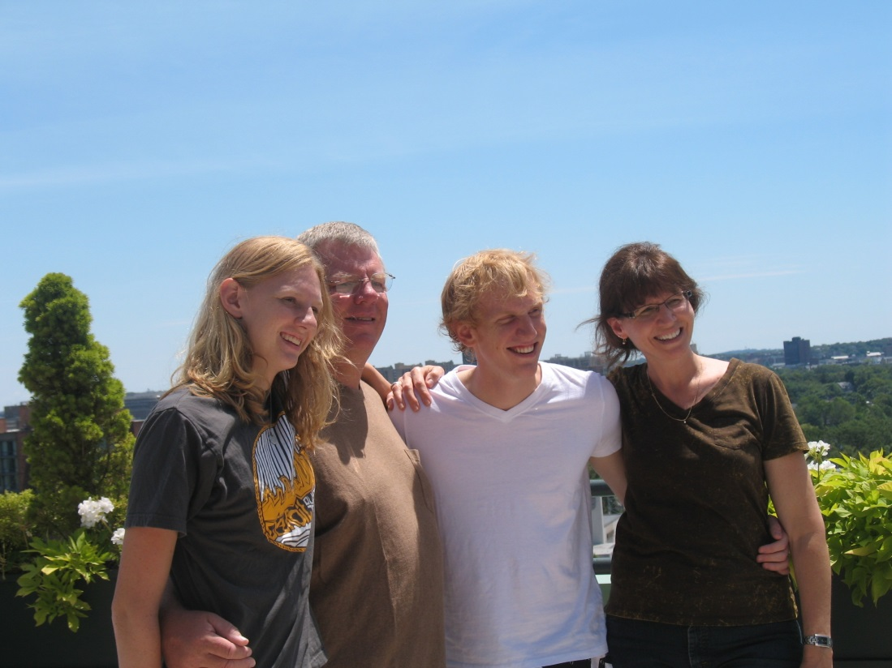

(l-r) Jacquelyn Michelle Schwartz, John (Jack) Edward Schwartz, Robert John Schwartz,

Pamela Anne Harrington Schwartz at Greg and Leah’s Wedding, Boston – 3 July 2010

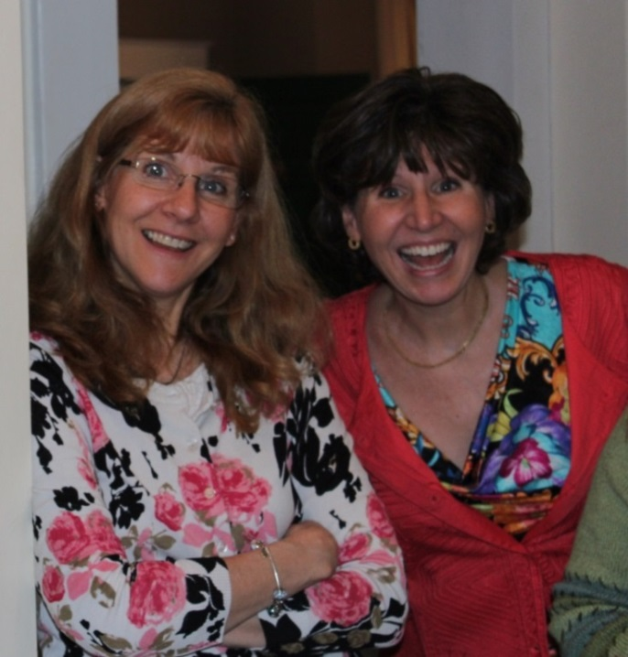

Margaret (Peggy) Elaine Harrington Poole and

Pamela Anne Harrington Schwartz - March 2013